# MyBar User Guide

MyBar is an Android app where the user can add his or hers bottles of spirits. The application will then compile a list of drinks that could be made with those spirits. For example, if you add Rum and Coke, the application will tell you that you can make a Cuba Libre!

You can also add favorite drinks and spirits as well as searching for the next great drink that you want to make.

## What you can do

* Browse a list of drinks in the collection
* Add an ingredient to your inventory
* Look at the information about a drink
* Add a drink to your favorites
* Share the app
* Rate a drink
* Get lists of drinks you can make with your inventory

## What you can’t do

* Give comments
* Add your own drinks
* Get feedback from other users of the app

# Application

This is the front page of the application, from here you can see which 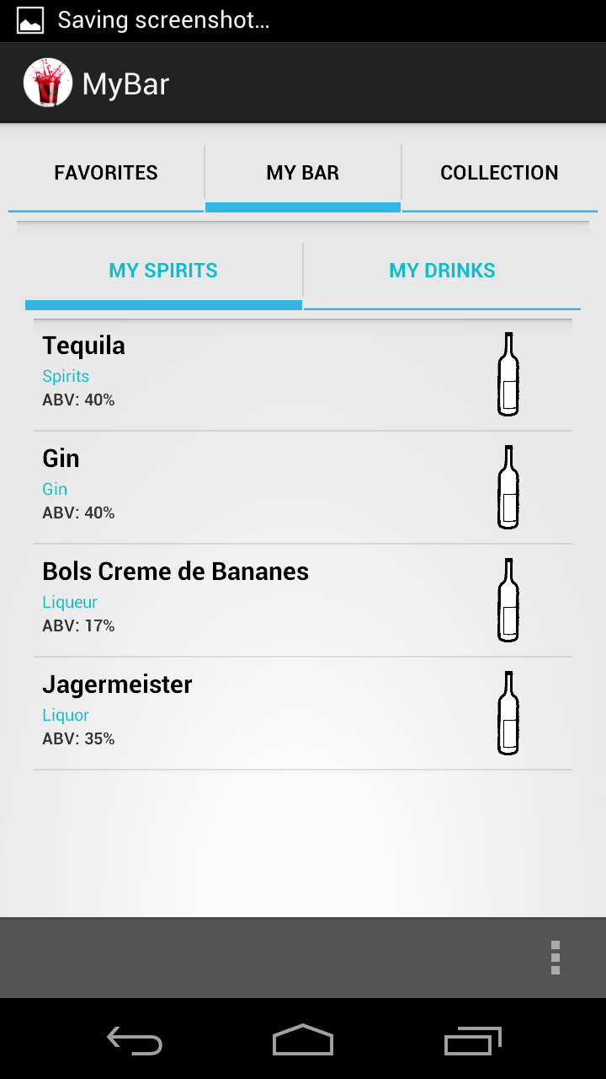spirits and soft drinks you are currently having in your bar.

To add a spirit or soft drink, press the menu button and then Add Spirits.

To add a spirit, simply press the spirit you want to add. You will be 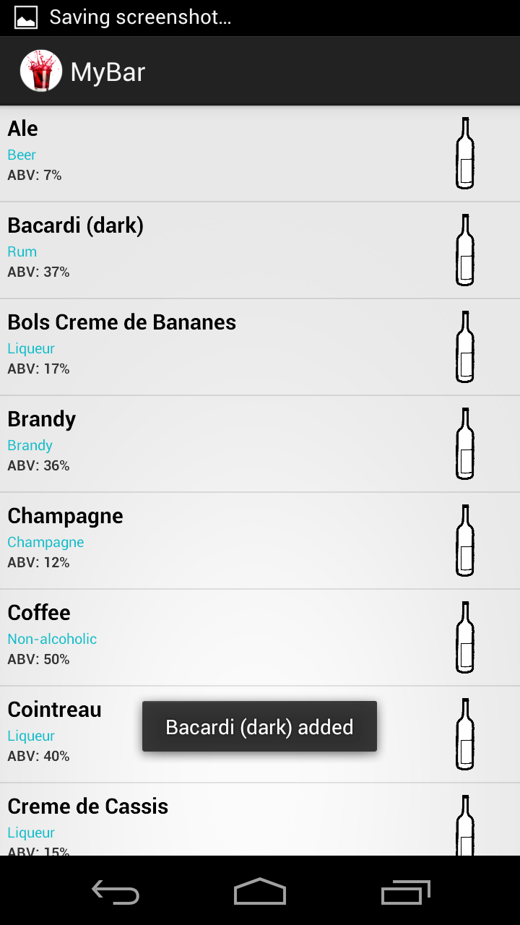informed with a toast that the spirit has been added.

If you press the MY DRINKS button you will get information about which 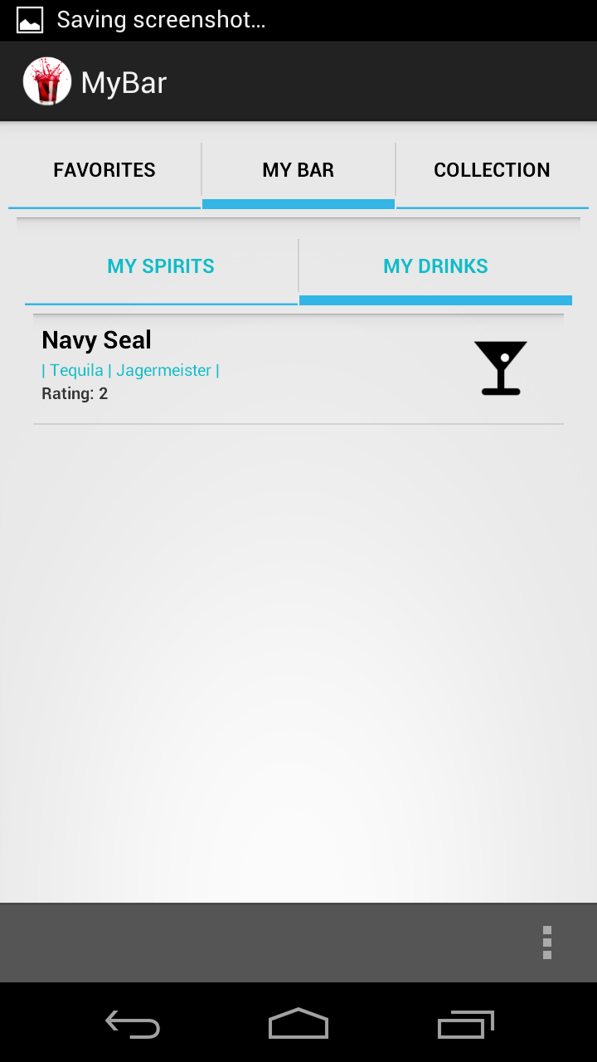drinks you can make out of the spirits you are having in your bar.

It is possible to share information from the MyBar application. This is not yet fully implemented, when it is. The user will be able to share it’s 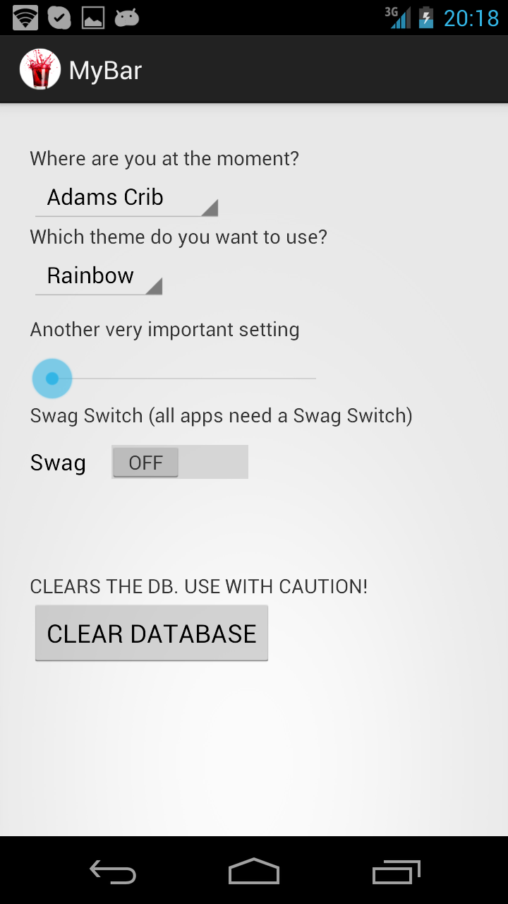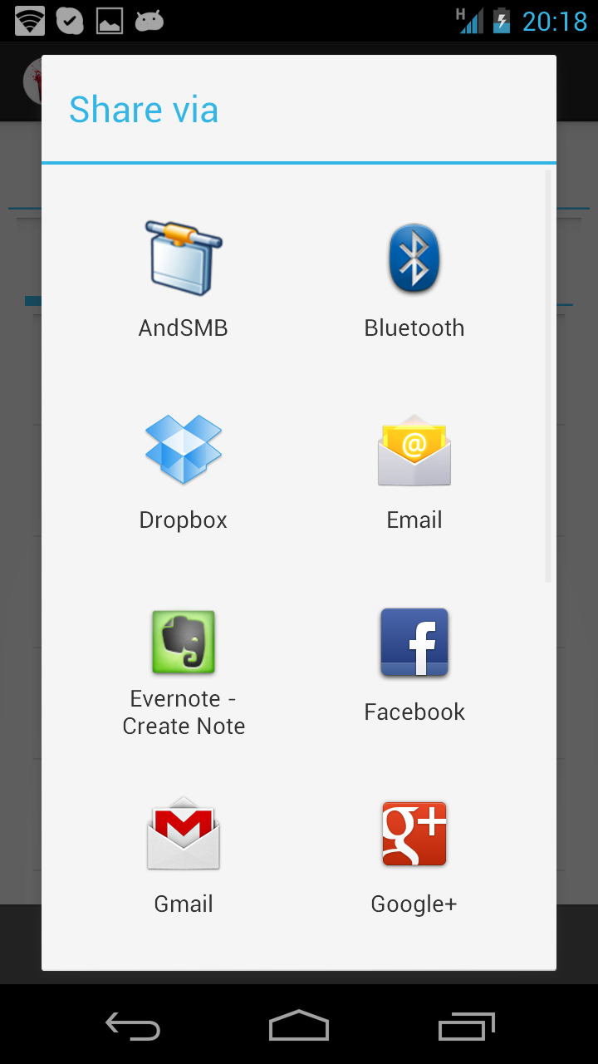favorite drink on for example Facebook.

In the future when these settings are implemented the user will have the possibility to change where they’re at. This means that they can have more than one bar. Which means that the application will show which drinks they can make at that location.